# Flashing LED

## Schematic diagram of the circuit

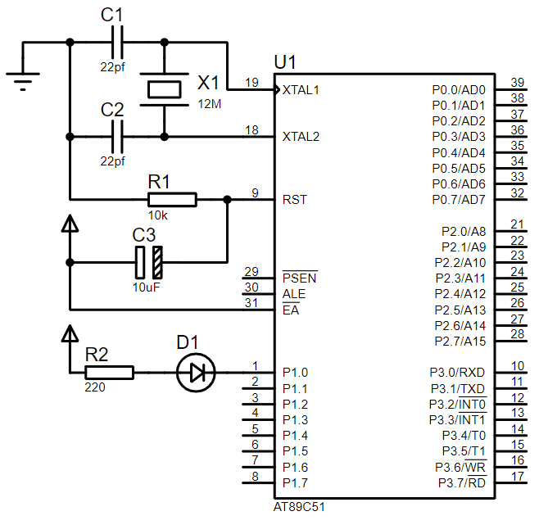

## Code

/* Project Name：Flashing LED

Note：LED flashes at set intervals.

*/

#include<reg51.h>

#define uchar unsigned char

#define uint unsigned int

sbit LED=P1^0;

//Delay x millisecond

void DelayMS(uint x)

{

uchar i;

while(x--)

{

for(i=0;i<120;i++);

}

}

//Main function

void main()

{

while(1)

{

LED=~LED;

DelayMS(150);

}

}

# Marquee

## Schematic diagram of the circuit

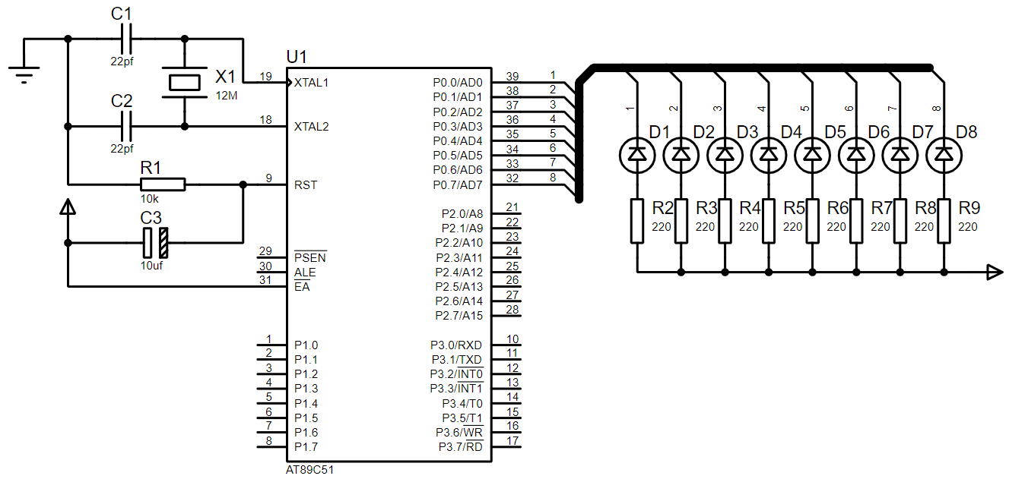

## Code

#include <reg52.h>

#include <intrins.h>

#define uchar unsigned char

#define uint unsigned int

void DelayMS(uint x)

{

uchar i;

while(x--)

{

for(i=120;i>0;i--);

}

}

void main()

{

P0 = 0xFE;

while(1)

{

P2 = _crol_(P0,1);

DelayMS(150);

}

}

# Static display of digital tube

## Schematic diagram of the circuit

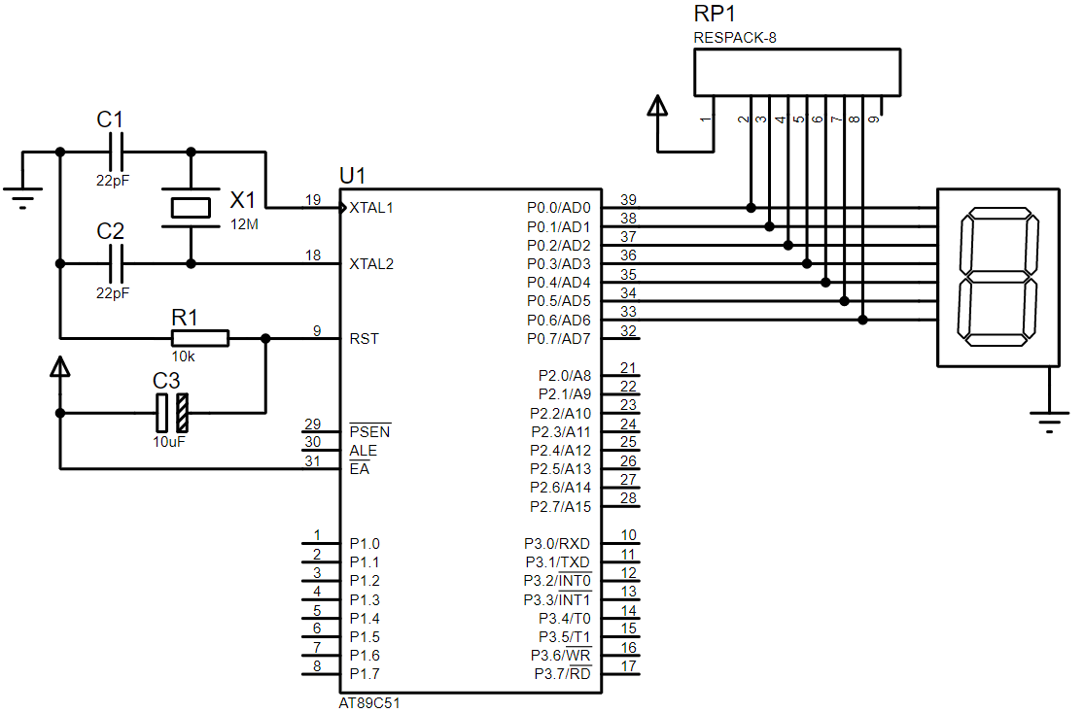

## Code

#include <reg52.h>

#include <intrins.h>

#define uchar unsigned char

#define uint unsigned int

uchar code DSY_CODE[]=

{

0xc0,0xf9,0xa4,0xb0,0x99,0x92,0x82,0xf8,0x90,0xff

};

void DelayMS(uint x)

{

uchar t;

while(x--)

for(t=120;t>0;t--);

}

void main()

{

uchar i=0;

P0=0x00;

while(1)

{

P0=~DSY_CODE[i];

i=(i+1)%10; // Display 0-9

DelayMS(200);

}

}

# Dynamic display of digital tube

## Schematic diagram of the circuit

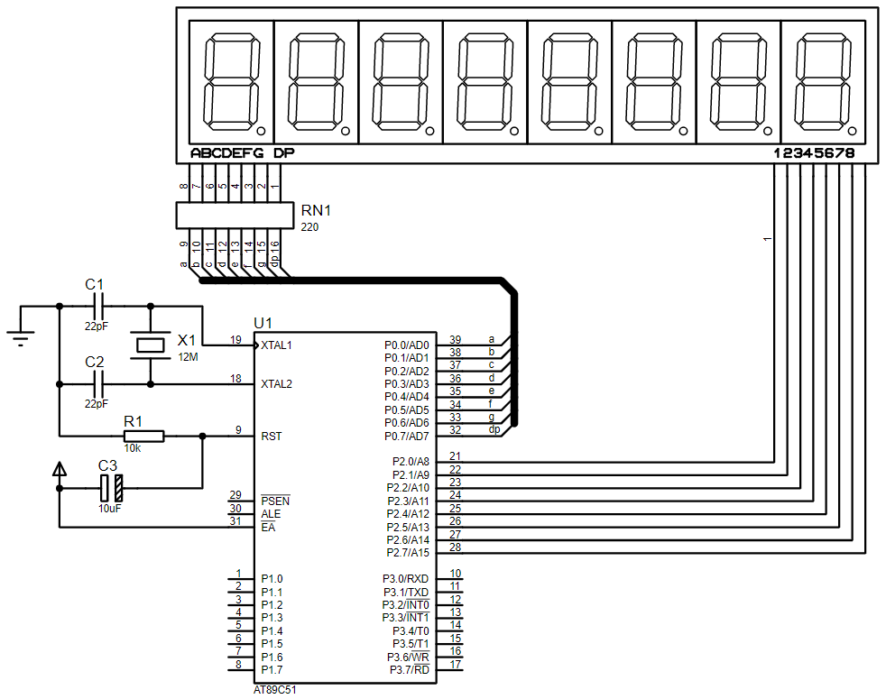

## Code

#include <reg52.h>

#include <intrins.h>

#define uchar unsigned char

#define uint unsigned int

uchar code DSY_CODE[]=

{

0xc0,0xf9,0xa4,0xb0,0x99,0x92,0x82,0xf8,0x80,0x90

};

void DelayMS(uint x)

{

uchar t;

while(x--)

{

for(t=120;t>0;t--);

}

}

void main()

{

uchar k,m=0x80;

P0=0xff;

P2=0x00;

while(1)

{

for(k=0;k<8;k++)

{

m=_crol_(m,1);

P2=m;

P0=DSY_CODE[k+1];

DelayMS(5);

}

}

}

# Independent key trigger

## Schematic diagram of the circuit

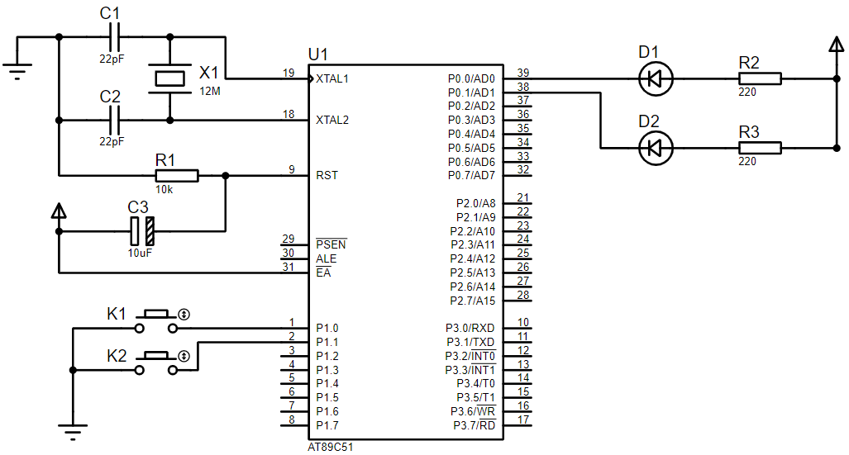

## Code

#include <reg52.h>

#define uchar unsigned char

#define uint unsigned int

sbit LED1 = P0^0;

sbit LED2 = P0^1;

sbit K1 = P1^0;

sbit K2 = P1^1;

void DelayMS(uint x)

{

uchar t;

while(x--)

{

for(t=120;t>0;t--);

}

}

void main()

{

P0=0xff;

P1=0xff;

while(1)

{

LED1 = K1;

LED2 = K2;

DelayMS(10);

}

}

# Matrix key trigger

## Schematic diagram of the circuit

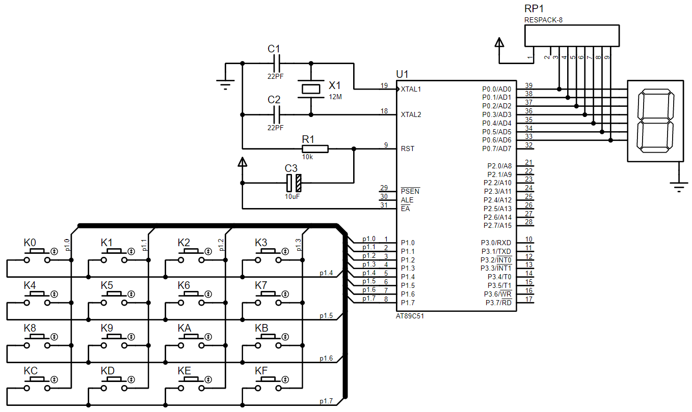

## Code

#include <reg52.h>

#define uchar unsigned char

#define uint unsigned int

uchar code DSY_CODE[]=

{

0xc0,0xf9,0xa4,0xb0,0x99,0x92,0x82,0xf8,0x80,0x90,0x88,0x83,0xc6,0xa1,0x86,0x8e,0x00

};

uchar Pre_KeyNO = 16,KeyNO = 16;

void DelayMS(uint ms)

{

uchar t;

while(ms--)

{

for(t=0;t<120;t++);

}

}

void Keys_Scan()

{

uchar Tmp;

P1 = 0x0f;

DelayMS(1);

Tmp = P1 ^ 0x0f;

switch(Tmp)

{

case 1: KeyNO = 0; break;

case 2: KeyNO = 1; break;

case 4: KeyNO = 2; break;

case 8: KeyNO = 3; break;

default: KeyNO = 16;

}

P1 = 0xf0;

DelayMS(1);

Tmp = P1 >> 4 ^ 0x0f;

switch(Tmp)

{

case 1: KeyNO += 0; break;

case 2: KeyNO += 4; break;

case 4: KeyNO += 8; break;

case 8: KeyNO += 12;

}

}

void main()

{

P0 = 0x00;

while(1)

{

P1 = 0xf0;

if(P1 != 0xf0)

Keys_Scan();

if(Pre_KeyNO != KeyNO)

{

P0 = ~DSY_CODE[KeyNO];

Pre_KeyNO = KeyNO;

}

DelayMS(100);

}

}